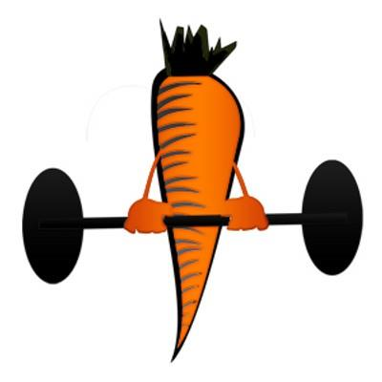
BodyDesigns Online Training Packages

Training

Price

4 weeks total body/2 per week
4 weeks total body/3 per week

$100
$125

Price includes 2 or 3 weight workouts based on the equipment you have available – either gym workouts or free weight home based workouts. A cardio plan is also included if desired.

Nutrition Plans can be added on to the Online Training

Lifestyle Diet Plan – includes a 1 hour consultation by Zoom or in person along with a personal diet plan and daily coaching for a month – cost $475

Lifestyle Diet Plan Detox Plan – add the Two Week Detox Plan for just $25 more and get an extra month of coaching

Nutrition Coaching - $75/month – with coaching I monitor your daily food intake giving you feedback and teaching you along the way as you strive to make healthy changes to your diet and meet your goals.

Coaching is through an APP where I can see your food logs and give you direct feedback each day. As your coach you have the ability to ask me questions and seek additional help with your dietary struggles and questions.

