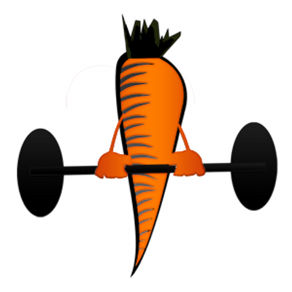

BodyDesigns introduces Lifestyles Weight Management System

Lifestyles Weight Management System is a comprehensive 8 week program that will guide you through making permanent changes in diet and exercise habits to achieve all your fitness and health goals once and for all! Lose weight, improve your health, increase your strength, improve your cardiovascular endurance and even improve your golf or tennis game!

Mary Sabat MS, RDN, LD, an ACE certified Personal Trainer and Nutritionist, will work with you both one on one and online to help you transform your habits once and for all. Make this the last diet and exercise program you ever try! Change your lifestyle, don’t just start a program. Lifestyles Weight Management System will have you looking and feeling great!

8-Week program includes:

Initial Health Risk Assessment
Nutritional Assessment
Measurements for body composition
Custom Lifestyle Diet Plan based on your goals, likes, dislikes and any limitations
Daily monitoring of food logs for accountability and learning
Weekly one on one personal trainer session
Weight online training program to compliment the in person sessions
Aerobic conditioning program to do on your own
Unlimited email and text
Follow up scheduled phone consults as needed

Rates:

Individual rate for 8 week program in my gym: $800
Join with a friend and 2nd person is half price - $400

Re-sign without a diet plan for an individual - $700
Re-sign without a diet plan for 2nd person is half price - $350

